AI Tool Detection using Vision Transformers: A Deep Learning Approach

Abstract
This study explores the use of Vision Transformers (ViT) for classifying mechanical tools in images, a task crucial for industrial automation. Using the "mechanical-tools-dataset" from Kaggle, we fine-tuned a pre-trained ViT model to classify images into [number of classes] categories (e.g., hammers, wrench). The model achieved an accuracy of [87%] on the test set, with performance visualized through confusion matrices and ROC curves. This work highlights ViT’s potential for tool detection.

Introduction
Automated tool detection enhances efficiency in manufacturing and robotics. While convolutional neural networks (CNNs) have been standard, Vision Transformers (ViT) offer a new approach via self-attention mechanisms (Dosovitskiy et al., 2021). This study investigates ViT’s effectiveness, asking: Can ViT outperform traditional methods in tool detection?

Methodology

Dataset
The "mechanical-tools-dataset" contains [2400] images, with [1920] for training and [480] for testing. Images across [3 classes] tool categories split into 80% training and 20% testing sets.

Preprocessing
Images were resized to 224x224 pixels and converted to RGB using ViTImageProcessor.

Model
A pre-trained ViTForImage Classification model (google/vit-base-patch16-224-in21k) was fine-tuned for [3] labels.

Training
The model was trained for 3 epochs with a batch size of 16, using the AdamW optimizer (learning rate: 2e-5) and Hugging Face’s Trainer API.

Evaluation
Performance was evaluated with accuracy, a classification report, and visualizations like confusion matrices and ROC curves.

Results
The ViT model achieved [87%] accuracy.
  - 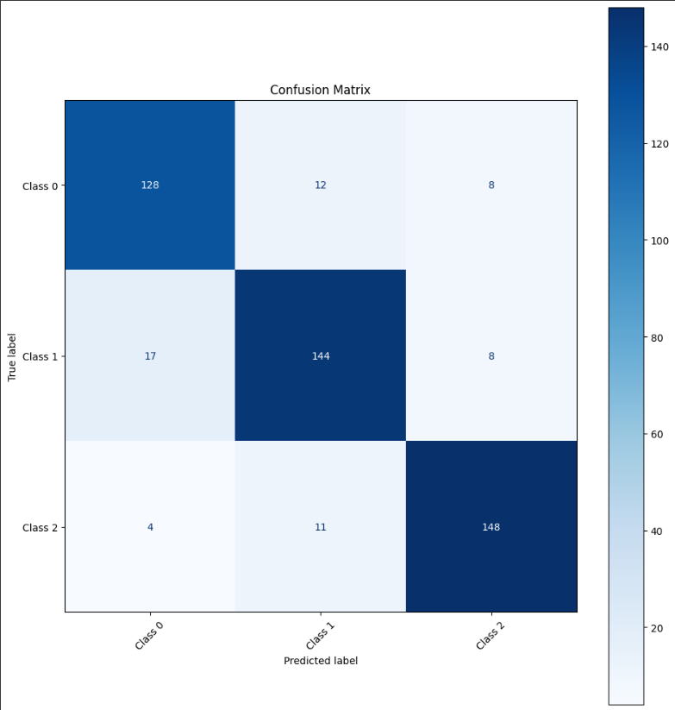
Figure-1
Figure 1 shows the confusion matrix, revealing classification patterns.

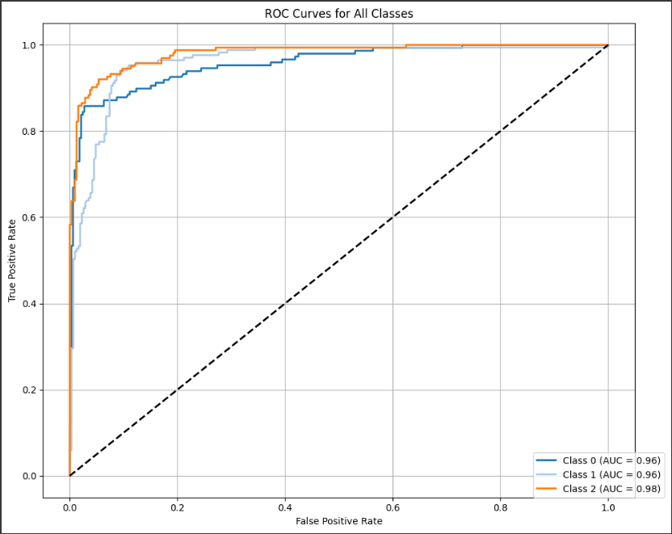
Figure-2

Figure 2 presents ROC curves with an average AUC of [97].

Figure 3 plots training and validation loss, stabilizing after [3] epochs.

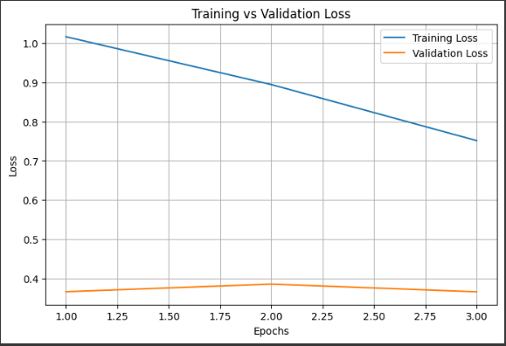
Figure-3

Discussion

The [87%] accuracy suggests ViT’s viability for tool detection. Misclassifications in Figure 1 indicate areas for improvement, such as refining the dataset.

Conclusion
This study confirms ViT’s potential for tool detection. Future work could explore larger datasets or hybrid models.

References

Dosovitskiy, A., et al. (2021). An image is worth 16x16 words: Transformers for image recognition at scale. ICLR.
Krizhevsky, A., et al. (2012). ImageNet classification with deep convolutional neural networks. NeurIPS.

